**SPIRIT, SOUL, BODY (4)** 2021-02-21

**1 THESSALONIANS 5:23(NKJV)** Now may the God of peace Himself sanctify you completely; and may your whole ***spirit, soul, and body*** be preserved blameless at the coming of our Lord Jesus Christ

* In this fourth instalment of this series, we’re going to shift our focus from the body, to the soul
* For the purposes of this study, ***the soul is not our spirit being*** which becomes born again but rather ***the seat of our appetites desires emotions and passions***
* If eating correctly is what is needed to have healthy thriving bodies, what can we do have healthy thriving souls? In other words, what must we do, to have our appetites, desires, emotions and passions, thriving in a Godly way?
* To answer this questions we must first understand the dynamics between the spiritual realm and the natural realm
* The spiritual realm is where the devil strategises and plans our destruction
* The natural realm, or the realm of the soul, is where he implements he’s plan. In other words, ***our soul is the devil’s battle ground***
* The following two verses, clearly defines God’s effective strategy, that will enable us to overcome any attack from satan. ***Focusing on anything else, is dangerous compromise!***
* Spending just five minutes, listening to people’s conversation, will clearly indicate what they’re focusing on the most
* What’s fascinating, is listening to what Christians talk about most, when they’re together.

**PHILIPPIANS 4:8-9(NLTSE)** “And now, dear brothers and sisters, one final thing. ***Fix your thoughts*** on what is ***true***, and ***honourable***, and ***right***, and ***pure***, and ***lovely***, and ***admirable***. Think about things that are ***excellent*** and ***worthy of praise***. 9 Keep putting into ***practice*** all you ***learned*** and ***received*** from me, everything you ***heard*** from me and ***saw me doing***. Then the God of peace will be with you”

* Our souls have five gates or entrances, through which God and the devil can work. These gates or entrances are our five senses: sight, touch, taste, smell, hearing
* We need to keep faithful watch over these senses, ensuring that the enemy does not enter through any one of them
* We’ve already dealt with our four basic ***appetites***, extensively, in our discussions on our bodies and what we should be eating: ( food, material, spiritual, sexual)

**PHILIPPIANS 3:18-19(NLTSE)** “For I have told you often before, and I say it again with tears in my eyes, that there are many whose conduct shows they are really enemies of the cross of Christ. 19 They are headed for destruction. ***Their god is their appetite***, they brag about shameful things, and they think only about this life here on earth.”

* What should our ***desires*** be based upon?

**PSALM 37:4(NLTSE)** Take delight in the Lord, and He will give you your heart’s desires.

* When we desire the Lord more than other things, He’ll give us more of Himself, or reveal more of Himself to us as we become hungrier for Him
* What should our ***emotions*** be based upon? For a start, let’s just deal with anger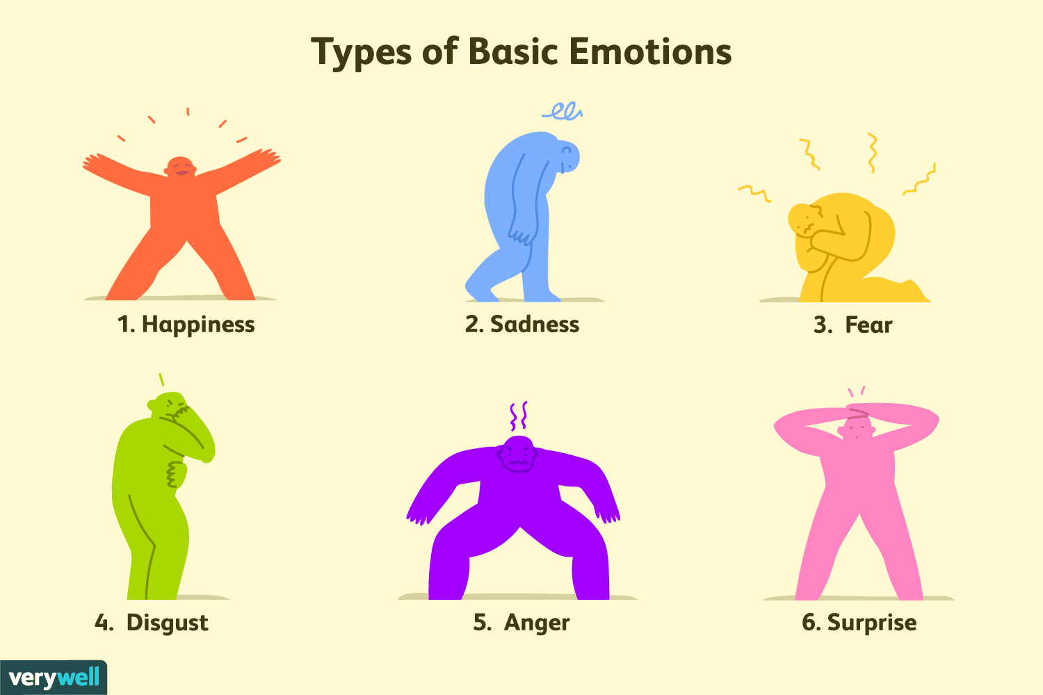

**PSALM 4:4(NLTSE)** Don’t sin by letting anger control you. Think about it overnight and remain silent.

* Getting angry is not a sin. Let’s just not sin while angry. Even Jesus got angry:

**MARK 3:5(NLTSE)** He looked around at them angrily and was deeply saddened by their hard hearts.

* What about jealousy?

**JAMES 3:14-16(NLTSE)** “But if you are bitterly jealous and there is ***selfish ambition*** in your heart, don’t cover up the truth with boasting and lying. 15 For jealousy and selfishness are not God’s kind of wisdom. Such things are earthly, unspiritual, and demonic. 16 For wherever there is jealousy and selfish ambition, there you will find disorder and evil of every kind.”

* What should our ***passions*** be based upon?

**PSLAM 69:9(NLTSE)** Passion for your house has consumed me

**JOHN 2:13-17** (we see the passion which Jesus had for the things pertaining to God’s temple

* Are we this passionate, about the things pertaining to the gathering places of God’s people and the continued fellowship of His people?
* In **PHILIPPIANS 4:9** Paul mentions five key factors:

1. Practice: we have to do something
2. Leaned: we must remain teachable
3. Received: we must take hold of what we’re taught
4. Heard: we must hear ***and*** listen. This means apply what we hear
5. Saw: we must watch the Godly example of others and do the same

* How can we apply **PHILIPPIANS 4:8-9,** in a practical way in our lives? We do this by focusing on Jesus Christ:

**HEBREWS 12:1-2(NLTSE)** “Therefore, since we are surrounded by such a huge crowd of witnesses to the life of faith, let us strip off every weight that slows us down, especially the sin that so easily trips us up. And let us run with endurance the race God has set before us. We do this by ***keeping our eyes on Jesus***, the champion who initiates and perfects our faith. Because of the joy awaiting Him, He endured the cross, disregarding its shame. Now He is seated in the place of honour beside God’s throne”

**CARE GROUP DISCUSSION**

1. Discuss the concept of our minds being the devil’s battle ground
2. Discuss how applying **PHILIPPIANS 4:8-9**, can keep our souls strong
3. Discuss the different aspects of our souls, in other words, our appetites, desires emotions and passions. How can these things be used to bring glory to God?
4. What areas of your soul are weak, because of not focusing on Jesus enough?
5. What areas of your soul, have been strengthened, because of focusing on Jesus?